Trusses, Angles, and Parallel Lines

A roof Truss is a structure made of wooden (or metal) beams that holds up a roof. In this activity, we will use the concepts from units 1 through 3 to investigate some roof trusses

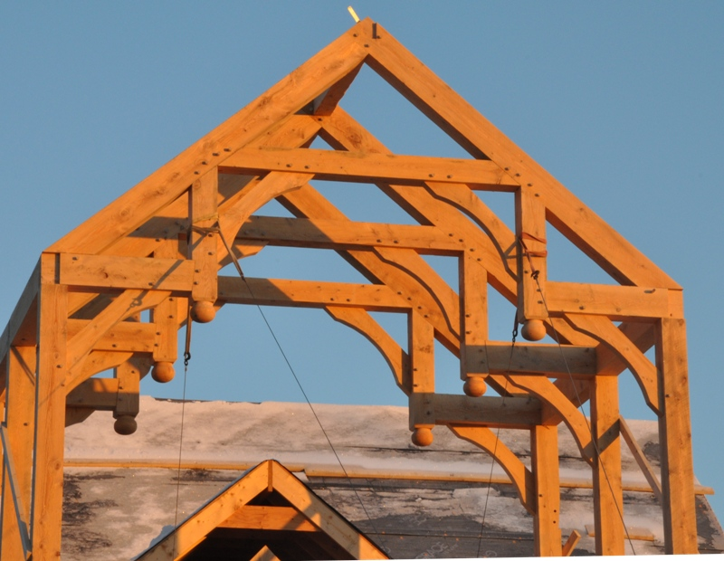***Suppose you are designing or building the roof truss to the right. Use the drawing to the right to answer the following questions.   
We know that $m‖n$.***

**1**

**2**

***m***

**3**

**4**

***n***

**5**

1. What type of angle pair are $∠1$ and $∠3$?
2. What type of angle pair are $∠1$ and $∠2$?
3. What type of angle pair are $∠2$ and $∠3$?
4. What type of angle pair are $∠2$ and $∠4$?
5. What type of angle pair are $∠5$ and $∠3$?

***Complete the sentence with what we know about the relationship of the angle pairs above (congruent, supplementary, complementary, etc.)***

1. Linear Pairs (like $∠3 and ∠4$) are ____________________________
2. If 2 lines are parallel, then corresponding angles are ___________________________
3. If 2 lines are parallel, then alternate interior angles are ________________________________
4. If 2 lines are parallel, then same-side interior angles are ________________________________

***Suppose you want to build the trusses so that $m∠1=60°$. What would the measurement of the other angles have to be.***



# [http://t2.gstatic.com/images?q=tbn:ANd9GcSpCPAgdUvd2xHDNYKh3uuwtg64nN2X-Lih6tdWCMypFKpDxyFf:rooftrussdesign.net/files/2011/04/wood_roof_trusses1.jpg](http://www.google.com/imgres?q=roof+trusses&hl=en&safe=active&biw=1053&bih=579&gbv=2&tbm=isch&tbnid=N0FWCWukn0eUqM:&imgrefurl=http://rooftrussdesign.net/timber-roof-trusses-wood-roof-trusses/&docid=cxYDWU2cmTyl7M&imgurl=http://rooftrussdesign.net/files/2011/04/wood_roof_trusses1.jpg&w=259&h=195&ei=MBG4TvqfG6qjiALc7aRp&zoom=1&iact=rc&dur=15&sig=117192120283310619466&page=3&tbnh=156&tbnw=207&start=19&ndsp=8&ved=1t:429,r:5,s:19&tx=92&ty=85)Graphing Trusses

**Now we want to design a truss by graphing lines on the same axes. So, graph the following lines on the axes below. Let each unit be a foot. Label each line with it’s equation.**








$y=\frac{1}{2}x+5$

$y=-\frac{1}{2}x+5$

$y=2x+1$

$y=-2x+1$

$y=1$

6. List any of the line pairs above that are parallel.   
    If none are parallel, explain why.
7. List any of the line pairs above that are perpendicular.   
    If none are perpendicular, explain why.
8. Darken all line segments inside the triangle made by (-8,1), (8, 1) and (0,5). If the lines don’t make a triangle at these points, then check your graphs.
9. What is the distance formula: __________________________________________
10. What is the midpoint formula: _____________________________________________
11. Two vertices of the truss are (-8,1) and (0,5). This is one side of the truss.
    1. Find the length of the line segment between (-8,1) and (0,5).
    2. Find the coordinates of the midpoint of the line segment between (-8,1) and (0,5).